**VIETNAM VETERAN’S WALL OF HONOR PROJECT**

Local efforts are ongoing to raise one-half of the $500,000 it will take to permanently locate the Wall of Honor at Woodring Airport Veteran’s Park in Enid. We are told an anonymous donor will match $250,000. Donors raising $1,000 or more will have their names permanently inscribed as supporters.

Your Class of 1967 Reunion Committee members would like to suggest adding $5.00 to each 45th Reunion registration with the goal of raising $1,000 in support of the Wall. “EHS Class of 1967” will be proudly displayed on the list of supporters. The Vietnam War played a major role during our high school years. We all know someone who served; we all know someone who made the ultimate sacrifice. This fitting tribute will show that the Class of 1967 has not forgotten our brave men and women who served our country during and after our high school years.

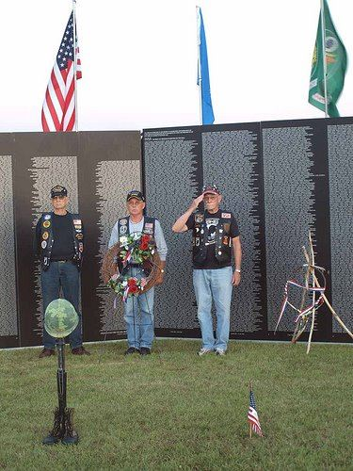“Applications are on file with the Kirkpatrick Foundation, Chesapeake, Devon Energy, and others for a grant to secure an 80% scale replica of the AVTT Vietnam Wall. Pray that some of our Oklahoma businesses will see the vision of the Vietnam Memorial Wall with their name on it as the primary sponsor and give us the matching funds we need to complete this project. Our state has a unique opportunity to permanently receive this beautiful tribute. Let's work together to keep it in Oklahoma for the Veterans who are the biggest advocates and supporters of today’s warriors. Let's give them the honor and respect they deserve. Their sacrifices have given us some of the support programs our current Veterans are receiving today! For the Oklahoma families who lost a child, husband, or sibling to the Vietnam War, for the 36 Oklahoma POW/MIAs, to the families of our current day heroes.... The Wall of Honor vows to never forget. The picture shown is the Wall we can secure permanently. It was taken Memorial Day Week, 2010.” (from Facebook)

The Wall of Honor Project administrators will return all donations if the fund raising is unsuccessful. Funds returned to EHS Class of 1967 will be held as preliminary funding for our 50th reunion in 2017.